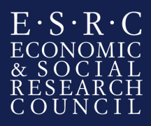
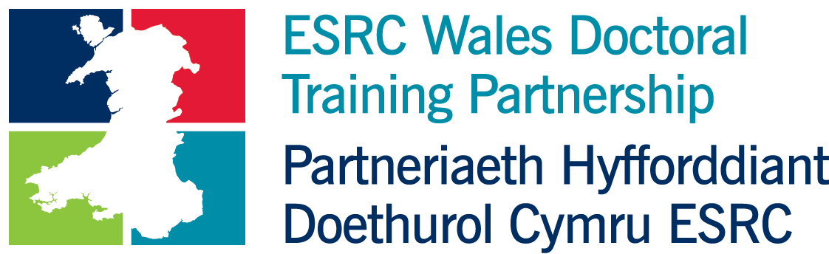

Welsh Government: Perceptions and self-reporting of Welsh language competence

Organisation / department background
The Welsh Government is the devolved government for Wales, and is responsible for a wide range of policy areas including:
- education
- Welsh language
- health
- local government
- transport
- planning
- economic development
- social care
- culture
- environment
- agriculture and rural affairs
- tourism
The role of the Welsh Government is to make decisions on matters regarding these areas, for Wales as a whole, develop policies and implement them, and propose Welsh laws. Civil Servants in the Welsh Government serve Welsh Cabinet Secretaries and Ministers working on matters devolved to Wales.
The UK government is still responsible for certain public services in Wales, for example police, prisons and the justice system. Matters such as tax and benefits, defence, national security and foreign affairs are also dealt with by the UK Government.
Further information on the Welsh Government is available at: http://wales.gov.uk
The intern will be based in the Welsh Language Research Branch in Knowledge and Analytical Services, working closely with both social researchers and policy professionals. The internship would provide an opportunity to apply research skills in a policy environment, further develop generic skills (such as report writing and making presentations), and to enhance policy knowledge.
More information about statistics and research at the Welsh Government:
http://gov.wales/statistics-and-research/about/?lang=en

Project brief

The Welsh Government’s Knowledge and Analytical Services, in collaboration with the Welsh Language Division, have identified the need to improve our understanding of how individuals view and report on their ability in Welsh, and what prompts them to describe their ability in certain ways. Obtaining accurate data about Welsh language ability underpins the work that will be required to monitor the Welsh Government’s progress towards a million Welsh speakers by 2050. Statistical work is currently under way to gain a better understanding of how respondents answer questions on their ability in Welsh in different surveys, and this project will seek to explore some of the possible reasons behind the reporting.
The census figures provide our starting point for understanding how many people are able to speak Welsh in Wales; these are derived from a self-assessment of Welsh language skills. In the 2011 Census (as in 2001) respondents in Wales were asked if they were able to understand spoken Welsh, speak Welsh, read Welsh and write Welsh (or if they had no ability in Welsh). Information about ability in Welsh is also collected through the National Survey for Wales (NSW). In addition the NSW asks respondents for an assessment of their ability in spoken Welsh (from ‘fluent’ to ‘a few words’), and asks about frequency of use. The Annual Population Survey (APS) also asks whether respondents are able to speak Welsh, and about frequency of use. The question about Welsh language ability included in the APS and the NSW is identical to that included in the Census. However, the proportion of people who state that they can speak Welsh is higher for these surveys than it is for the Census. There is a possibility that differences in how these surveys and the Census are carried out are likely to influence the results (that is, self-completion questionnaires in the case of the Census compared to face-to-face or telephone interviews for the surveys). More generally, the subjectivity involved in self-assessments of Welsh language ability is recognised, but further work is required to understand the factors underlying speakers’ perceptions and reporting.

The aims and objectives of the project

The aim of this project is to provide a basis for an exploration of the factors that could be underlying respondents’ assessments of their ability in Welsh. This work is intended to improve our understanding of the considerations that need to be borne in mind when interpreting the significance and reliability of individuals’ assessments of their language ability. It is also envisaged that the findings could, over time, contribute to the process of improving or refining the way in which information is collected about respondents’ Welsh language skills.
The primary focus of the study will be on the ability to speak Welsh, although it is also possible that the work could raise questions about abilities in understanding, reading and writing that would merit further investigation in subsequent research.
The researcher will undertake:

- A review of the different methods that have been used to collect information about respondents’ Welsh language ability, and the assessments that have already been undertaken of the reliability of the methods used;

- A review of the methods used in settings other than Wales to collect information about language ability in censuses and surveys, with the aim of understanding their relevance to the Welsh context;

- An exploration of the considerations and challenges associated with collecting information about Welsh language skills, in the wider context of the literature on speaker perceptions of language proficiency and fluency.

Subject to the skills and experience of the successful applicant, the project could also include an additional element of developing initial proposals for qualitative research, to explore in greater detail (at a later date and beyond the scope of this internship) the factors associated with respondents’ perceptions about their Welsh language ability.
The project requires one intern for a period of up to 3 months.

The anticipated project outcomes
- A report presenting the findings of the research undertaken
- A presentation to analytical and policy colleagues on the findings of the research.

Student specification

The student must have:
- Strong research and analytical skills including experience of undertaking literature and scoping reviews;
- Experience of analytical work in the areas of language assessment and/or language acquisition; sociolinguistics, and language planning;
- The ability to produce concise, well-written documents in an accessible format.

Language skills requirements:
This project will require the student to access and read material in Welsh and English. The student will therefore be required to demonstrate their ability to read academic and technical reports and papers in both languages.
The student will also need to demonstrate an awareness and understanding of the sociolinguistic features of Wales and how they relate to the aims of this project.

Start date of Internship

January 2018 (exact date to be negotiated)

Security
The Welsh Government’s vetting procedures (which apply to temporary as well as permanent staff) involve the completion of a Baseline Personnel Security Standard (BPSS) application form and a Security Questionnaire for the process of security vetting to Counter Terrorist Check (CTC), Security Check (SC) and Developed Vetting (DV).
Baseline Personnel Security Standard (BPSS) requires the applicant to produce in person, 3 original forms of Identification Documents, one of which should be photographic (passport, new driving license), one document should show the current address and the third form of ID could be an utility bill, birth certificate, P45 or P60.

Queries
Any queries relating to the project should be directed to:

Catrin Redknap (catrin.redknap@llyw.cymru; catrin.redknap@gov.wales)

http://gov.wales/topics/welshlanguage/welsh-language-strategy-and-policies/cymraeg-2050-welsh-language-strategy/?lang=en

