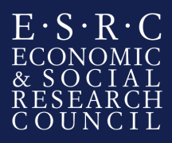
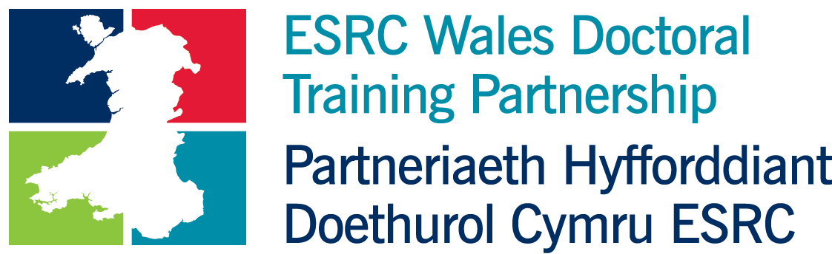

Welsh Government: Analysis of Well-Being Data in Relation to/with Natural Resources

Organisation/ department background
The Welsh Government is the devolved government for Wales, and is responsible for a wide range of policy areas including:
- education
- health
- local government
- transport
- planning
- economic development
- social care
- culture
- environment
- agriculture and rural affairs.
- tourism
The role of the Welsh Government is to make decisions on matters regarding these areas, for Wales as a whole, develop policies and implement them, and propose Welsh laws. Civil servants in the Welsh Government serve Welsh Cabinet Ministers and Deputy Ministers working on matters devolved to Wales.
Further information on the Welsh Government is available at: http://wales.gov.uk
This internship has been agreed through collaboration between the Welsh Government (WG) and Natural Resources Wales (NRW).

The intern will be based in the both the WG (in the EU Exit & Strategy Unit & the National Survey for Wales team) as well as in NRW, working closely with social researchers, statisticians and policy teams.

The internship will provide an opportunity to gain an insight into the work of the WG, and to apply research and statistical skills whilst further developing generic skills (such as team working, report writing and making presentations).

Given the collaborative nature of the studentship and working across two organisations, the successful candidate will be provided with a unique opportunity to gain valuable experience as a result of working with analysts and policy colleagues from both NRW & WG. This will include networking across offices and locations in Wales, making presentations to mixed audiences and leading small training courses.

Background

The National Survey for Wales is large scale, face to face survey of over 14,000 adults a year. It provides robust information on people’s views about a wide range of issues which are of interest to the Welsh Government. The survey includes topics such as childcare, play, internet use, e-safety, media, pets, arts, museums, public services (e.g. health, education and local authorities), material deprivation, and well-being.

NRW input a number of question sets into the national survey on topics focusing on people and the environment, including citizen’s perception of climate change, flood risk, and biodiversity, participation in outdoor recreation, and pro-environmental behaviours.

Both WG and NRW are producing some basic analysis of the survey data in first releases and in topic specific bulletins. The WG also produced a series of cross tabulations on the StatsWales website, and deposit the data sets in the UK Data Archive so that other researchers can access the data and analyse it for themselves.

Although both WG and NRW publish a wide range of cross tabulations of the survey data, we know that in many cases there is not a simple causal relationship between the variables that are cross-tabulated. Many other factors may contribute to the correlation and some apparent relationships between variables may no longer exist once other factors are controlled for.

Previously commissioned more in-depth analysis of the survey results has included regression analyses to identify what predicts different responses when other factors are controlled for. By combining the data from both WG and NRW we would like to be able to carry out further analyses to explore potential relationships between natural resources and well-being (including mental and physical health, economic factors, subjective well-being measures, and geographical inequalities).

The aims and objectives of the project

The aim of this project is to contribute to the development of both the WG’s and NRW’s approach to synthesising evidence and exploring the potential relationship between natural resources and well-being. This will contribute towards the evidence needed for new policy requirements (such as the Well-being Assessments in Wales), and help inform organisational and national indicators.

The objectives of this project are to explore and interpret the results of the National Survey for Wales to meet key policy and practice requirements. The researcher will:

- Working in partnership with topic specific evidence leads in NRW and the WG, review the data and associated evidence to define potential connections within the survey. The researcher will identify the most appropriate method for analysing the relationships between survey responses.
- Carry out appropriate analysis to explore the potential relationships on a range of topics. The topics would include a subset of the following (the exact set of topics will be discussed and agreed on appointment):
- Benefits of engagement with the natural environment (including recreation and volunteering) for well-being (including physical and mental health, subjective well-being attributes, and other variables)
- Relationship between exposure to flood risk, and the impact on mental health and subjective well-being
- Attitudes to climate change, levels of concern, and pro-environmental behaviours
- Perceptions of biodiversity loss, levels of concern, and pro-environmental behaviours
- Draft a short series of topic specific ‘Insights’ reports based on a policy-informed interpretation of the results of the analyses
- Present the results of the analyses in a presentation to NRW and WG analysts and policy officials
- Run a training session with the team to demonstrate how to replicate the work in future.
- Consider any potential data or evidence gaps identified and how they might most appropriately be filled in the future
- Consider the potential for future research with different citizen groups (younger people, older citizens etc.) to explore in more depth the relationships highlighted in this research project
The internship would last for a period of 4 months.

The anticipated project outcomes
- High quality data and analysis to aid an understanding of the potential multi-variable relationships between wellbeing and natural resources
- A short series of topic specific ‘Insight Reports’
- A technical report which would include the following:
  - A review of what the data can tell us
  - A discussion of the different types of analysis which could be used on the survey data and recommendations on the best approach to use
  - A summary of the results of the analysis.
- Annotated syntax for carrying out the analysis, including any data preparation work (e.g. recoding of variables)
- A presentation to analytical colleagues and policy officials from both WG and NRW on the findings of the report.
- A training session with appropriate teams to demonstrate how to replicate the work in future.

Student specification

The student must have:
- Strong data analysis skills and experience with working on quantitative survey data.
- Experience in handling/manipulating data, in SPSS, Stata, or SAS.
- The ability to produce cross-tabulations, well designed charts and to produce concise, well written documents presenting technical material in an accessible format.

Start date of internship

The proposed state date of the student ship would be January 2018, although there may be some flexibility dependant on individual circumstances.

Security
The WG’s vetting procedures (which apply to temporary as well as permanent staff) involve the completion of a Baseline Personnel Security Standard (BPSS) application form and a Security Questionnaire for the process of security vetting to Counter Terrorist Check (CTC), Security Check (SC) and Developed Vetting (DV).
The BPSS requires the applicant to produce in person 3 original forms of Identification Documents. One document should be photographic (passport, new driving license), one document should show the current address and the third form of identification could be an utility bill, birth certificate, P45 or P60.

Queries

Any queries relating to the application process should be directed to:

- Lisa Walters (lisa.walters@gov.wales)
- Jo Amesbury (joanne.amesbury@gov.wales)
- Sue Williams (Susan.A.Williams@cyfoethnaturiolcymru.gov.uk)

