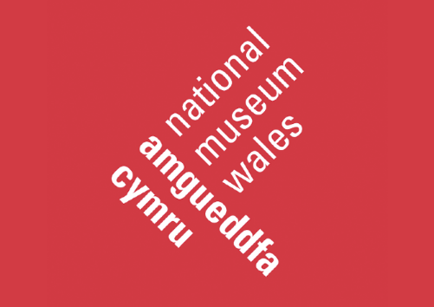

Developing Participatory Action Research at Amgueddfa Cymru

Summary
As part of Amgueddfa Cymru’s new Research Strategy (under development) participatory research will be one of the main tools for engaging and representing diverse communities across all our sites and areas of work.
We are currently developing a proposal to explore questions around the power structures and challenges for authentic representation within the museum and heritage sector such as:
- What needs to change in the relationships between museums and communities?
- Who has relevant knowledge? Who should have the power? How does that power manifest itself?
- Where do communities hold the power to drive culture change in museums?
- Where are the blind spots in community participation with museums and are these due to entrenched notions of power?
We want this proposal to be driven by the needs and priorities of the communities we serve. With this in mind we are offering this placement as part of an initial scoping exercise with communities to ensure that their views are represented in the final proposal.
We would like to offer a 3 month placement to a student in the social sciences to help us explore these questions (and more) with our communities and help them to select the research methodology, select appropriate methods and co-create ethical guidelines for the work.
The Organisation
Amgueddfa Cymru – National Museum Wales is committed to undertaking high quality research across the natural sciences, social sciences, arts and humanities. We have identified research as a key enabler to better understand our collections, improve visitor experience and support our move towards net zero carbon operation. As the only Independent Research Organisation in Wales we use the unique elements of our collections to deliver research that others cannot. The breadth of our expertise across all 7 of our sites allows us to conduct participatory research with communities that benefits everyone in Wales.
Our sites are located in a mixture of rural and urban areas across Wales and cover many aspects of Welsh history and culture. Our main site in Cardiff is the main home to our art and natural sciences collections and is the focal point for our research activity.
The organisation has a policy of flexible working hours with many people still working from home where appropriate. We have a dedicated team who support all those undertaking work placements with us. We are committed to supporting people from diverse backgrounds and those with protected characteristics. We support workplace adjustments to ensure that all employees have an environment in which they can thrive.
The Placement
The placement will be based across the Research Department and the Department of History and Archaelogy. The candidate will be working closely with the Heads of these departments as well as colleagues in the public engagement team.
We are developing this project in partnership with Glasgow Women’s Library, The Nerve Centre in Northern Ireland, The Wellcome Collection and Frân Wen. The candidate will need to work across all 5 organisations to help bring the partnership together offering support through e.g. running workshops or focus groups.
Through this placement the candidate will:
- Gain experience of community based participatory research processes.
- Develop their understanding of how participatory action research can be applied in the museums and heritage sector.
- Work with a diverse range of stakeholders and community groups across the UK.
- Gain experience of developing a large scale multi-partner research proposal.
The project
The candidate will:
- Undertake a light touch literature review of Participatory Action Research in sectors relevant to the project.
- Support the Head of History and Archeaology in planning and delivering a series of workshops with community members and external partners to gather data to shape the research proposal.
- Work with community groups to develop the research methodology for the proposal.
- Work with community groups to develop the ethical guidelines for the research.
Anticipated outcomes
- A brief overview of Participatory Action Research and its application to the Museums and Heritage sector to support proposal development.
- A refined set of research questions for the proposal.
- Recommendations for the research methodology co-developed with community participants
- A set of ethical guidelines for the research co-developed with community participants
Working arrangements
The Placement will last for three months, during which time the student’s PhD project will be paused by their home institution. The student will be paid the equivalent of their stipend during their internship. Over and above leave policies, time for existing PhD commitments can be arranged on discussion with line managers. E.g. research groups meetings and conference presentations. Applications are encouraged from part-time students.
It is anticipated that the successful applicant will be working from home during their internship. This is based on our current understanding of the situation and what is possible in terms of research work. This may change as the Covid-19 situation develops. Should the Covid-19 situation develop and allow for a return for a phased return to offices this will be discussed with successful applicants.

We anticipate the majority of workshops being run online, but where these are run face to face the candidate will be reimbursed for travel expenses.

The internship will last for a period of three months full-time or the part-time equivalent. For students registered on a part-time studentship, this internship is available on a part-time basis over a longer time frame (no fewer than three days a working week as this is a time sensitive project), this would be negotiated between the Amgueddfa Cymru and the successful applicant. If you would like to be considered on a part-time basis, please specify your preferred working hours on the application form.

Student Specification

The student must have;
- Strong literature review skills including the ability to synthesise evidence from a range of sources and present it in an easily understandable way to a non-specialist audience.
- Experience of participatory research.
- A sound understanding of a range of social science research methods appropriate for use with non-specialist audiences.
- Experience of planning and running workshops.
- A sound understanding of research ethics relevant to this type of project.
Anticipated start date
March 2022 (exact date to be negotiated). There may be some flexibility dependent on individual circumstances.

